|  |  |
| --- | --- |
| File:COMSATS new logo.jpg - Wikimedia Commons  ***PROGRAMMING FUNDAMENTALS***  LAB Assignment 01 | **submitted by:**  **Shahzaneer Ahmed**  **registration number:**  **SP21-BCS-087**  **submitted to:**  **MR. RIZWAN RASHID**  **date of submission:**  **October 29,2021** |

# Lab Assignment 01

Question 1

Source Code

// |----------------------------------------------------------|

// |------------------Shahzaneer Ahmed------------------------|

// |-------------------SP21-BCS-087---------------------------|

// |----------------------------------------------------------|

//Question – 1:

// Cindy uses the services of a brokerage firm to buy and sell stocks. The firm charges 1.5% service

// charges on the total amount for each transaction buy or sell. When Cindy sells stocks, she would

// like to know if she gained or lost on a particular investment. Write a program that allows Cindy

// to input the number of shares sold the purchase price of each share, and the selling price of

// each share. The program outputs the amount invested, the total service charges, amount gained

// or lost, and the amount received after selling the stock.

import java.util.Scanner;

public class Question_1 {

public static void main(String[] args) {

Scanner obj = new Scanner(System.in);

double BROKERAGE_SERVICE_CHARGES = 1.5/100;

System.out.println("Enter the no of shares sold : ");

double noOfShares = obj.nextDouble();

System.out.println("Enter the purchase price of each Share : ");

double purchasePrice = obj.nextDouble();

System.out.println("Enter the Selling price of each share : ");

double sellingPrice = obj.nextDouble();

double investedAmount = (noOfShares*purchasePrice);

double totalServiceCharges = noOfShares*sellingPrice*BROKERAGE_SERVICE_CHARGES;

double amountReceived = investedAmount+totalServiceCharges;

boolean amountGained = amountReceived>investedAmount;

boolean amountLost = amountReceived<investedAmount;

System.out.printf("The total invested amount is $ %.2f\n",investedAmount);

System.out.printf("The total amount received is $ %.2f\n",amountReceived);

System.out.printf("The total Service Charges are $ %.2f\n",totalServiceCharges);

if(amountGained) System.out.println("The Stock exchange was a gain!");

else if (amountLost) System.out.println("The Stock exchange was a lost!");

}

}

Screenshots

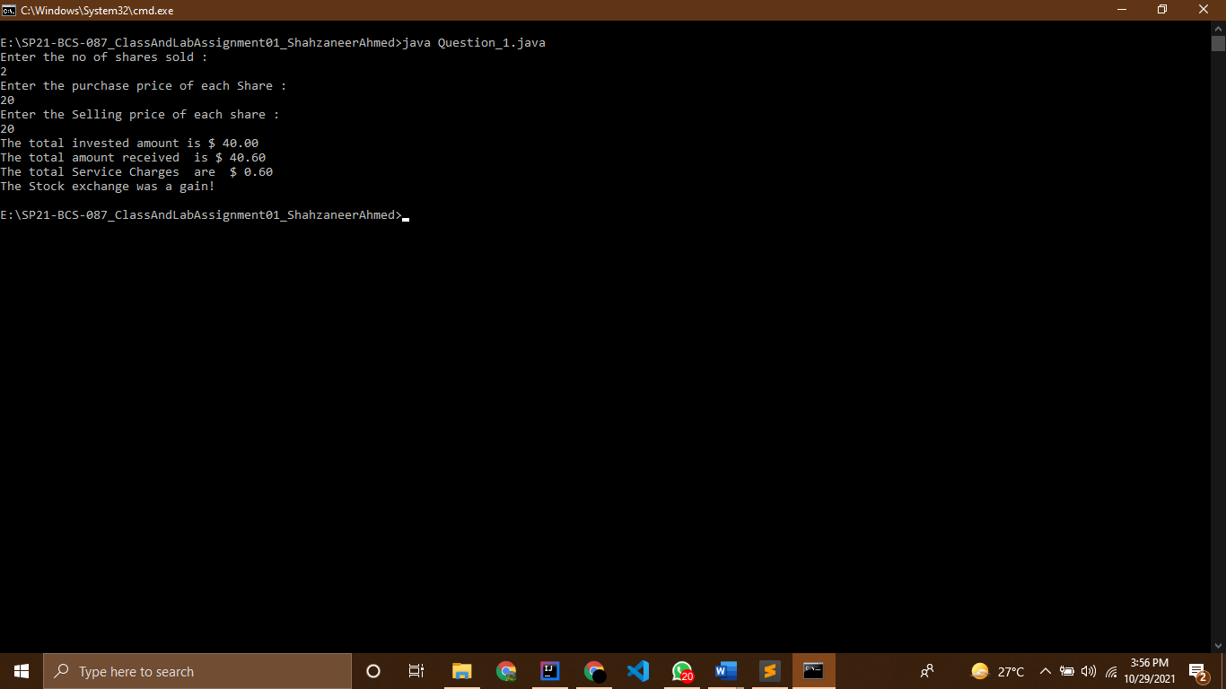

Question 2

Source Code

// |----------------------------------------------------------|

// |------------------Shahzaneer Ahmed------------------------|

// |-------------------SP21-BCS-087---------------------------|

// |----------------------------------------------------------|

//Question – 2: CLO-3

// Write a program that computes the cost of painting and installing carpet in a room. Assume that

// the room has one door, two windows, and one book-shelf. Your program must do the following

// ▪ Prompts the user to enter, in feet, the length, width, and height of a room. Read the

// dimensions of the room.

// ▪ Prompts the user to enter the widths and heights, in feet, of the door, each window,

// and the bookshelf. Read these quantities.

// ▪ Prompts the user to enter the cost, per square foot, of painting the walls. Read these

// quantities.

// ▪ Prompts the user to enter of cost, per square foot, of installing carpet. Read these

// quantities.

// ▪ Outputs the cost of painting the walls and installing the carpet.

import java.util.Scanner;

public class Question_2 {

public static void main(String[] args) {

Scanner obj = new Scanner(System.in);

// input for room

System.out.println("Enter the Length of the room in feet :");

double roomLength = obj.nextDouble();

System.out.println("Enter the width of the room in feet :");

double roomWidth = obj.nextDouble();

System.out.println("Enter the height of the room in feet :");

double roomHeight = obj.nextDouble();

// input for door

System.out.println("Enter the height of door in feet :");

double doorHeight = obj.nextDouble();

System.out.println("Enter the width of door in feet :");

double doorWidth = obj.nextDouble();

// input for book shelve

System.out.println("Enter the height of book-shelve in feet :");

double bookShelveHeight = obj.nextDouble();

System.out.println("Enter the width of book-shelve in feet :");

double bookShelveWidth = obj.nextDouble();

// input for windows :

System.out.println("Enter the height of first window in feet :");

double window1Height = obj.nextDouble();

System.out.println("Enter the width of first window in feet :");

double window1Width = obj.nextDouble();

System.out.println("Enter the height of Second window in feet :");

double window2Height = obj.nextDouble();

System.out.println("Enter the width of Second window in feet :");

double window2Width = obj.nextDouble();

// input for cost of painting the walls :

System.out.println("Enter the cost ,per square foot, of painting the walls :");

double costWallPainting = obj.nextDouble();

// input for cost of installing the carpet :

System.out.println("Enter the cost ,per square foot, of painting the walls :");

double costCarpetInstallation = obj.nextDouble();

// calculating cost of painting the walls :

double totalCostPainting = ((2 * (roomLength * roomHeight) + 2 * (roomHeight * roomWidth))

- (doorWidth * doorHeight) - (window1Width * window1Height) - (window2Width * window2Height)

- (bookShelveHeight * bookShelveWidth)) * costWallPainting;

double totalCostCarpetInstallation = (roomLength * roomWidth * costCarpetInstallation );

System.out.printf("The total cost for painting the walls is : $ %.2f\n",totalCostPainting);

System.out.printf("The total cost for installing the carpet is : $ %.2f\n",totalCostCarpetInstallation);

}

}

Screenshots

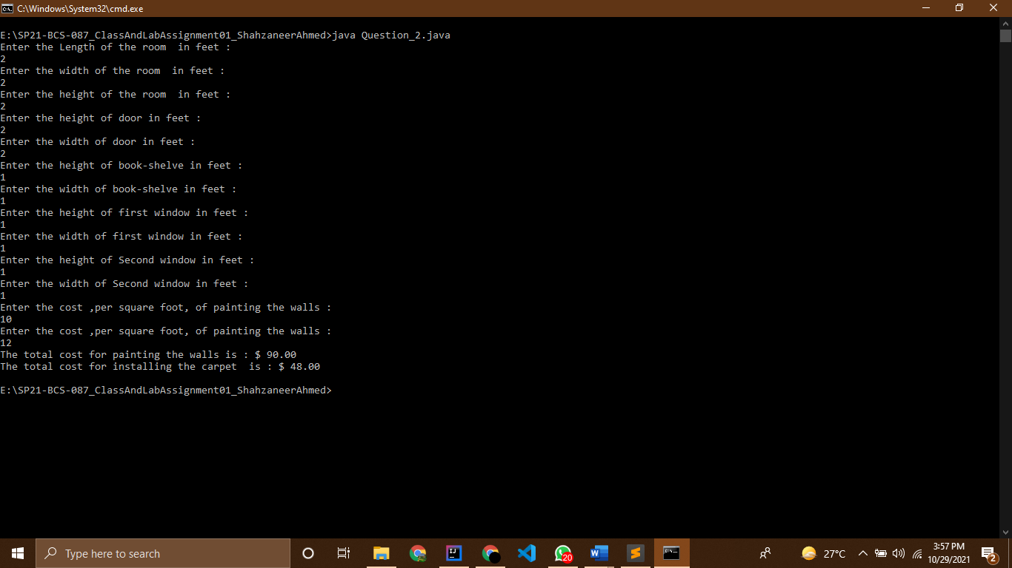

Question 3

Source Code

// |----------------------------------------------------------|

// |------------------Shahzaneer Ahmed------------------------|

// |-------------------SP21-BCS-087---------------------------|

// |----------------------------------------------------------|

//Question – 3:

// In the Chess game, King moves horizontally, vertically or

// diagonally to any adjacent cell as shown in figure. Given

// two different cells of the chessboard, determine whether a

// king can go from the first cell to the second in one move.

// Write a program that will receive the input of four

// numbers from 1 to 8, each specifying the column and row

// number, first two - for the first cell, and then the last two -

// for the second cell. The program should output YES if a

// king can go from the first cell to the second in one move

// or NO otherwise

//In chess, we know that there are 8 rows and 8 columns and a total of about 64 cells to move on!

import java.util.Scanner;

public class Question_3 {

public static void main(String[] args) {

Scanner obj = new Scanner(System.in);

System.out.println("Enter in between (1-8) ");

System.out.println("Enter the row no of first cell :");

int rowFirstCell = obj.nextInt();

System.out.println("Enter the Column no of first cell :");

int columnFirstCell = obj.nextInt();

System.out.println("Enter the row no of Second cell :");

int rowSecondCell = obj.nextInt();

System.out.println("Enter the column no of Second cell :");

int columnSecondCell = obj.nextInt();

int row, column;

boolean columnSubGreaterThanZero = (columnFirstCell - columnSecondCell > 0);

boolean rowSubGreaterThanZero = (rowFirstCell - rowSecondCell > 0);

if (rowFirstCell>8 || rowSecondCell>8 || columnFirstCell>8 || columnSecondCell>8) {

System.out.println("Invalid No of rows or column");

}

else {

if (columnSubGreaterThanZero) column = columnFirstCell - columnSecondCell;

else if (!columnSubGreaterThanZero) column = columnSecondCell - columnFirstCell;

else column = 0;

if (rowSubGreaterThanZero) row = rowFirstCell - rowSecondCell;

else if (!rowSubGreaterThanZero) row = rowSecondCell - rowFirstCell;

else row = 0;

if ((column == 1 && row == 0) || (column == 0 && row == 1) || (column == 1 && row == 1))

System.out.println("Yes! The king can move in a single step!");

else System.out.println("No! The king cannot move in a single step!");

}

}

}

Screenshots

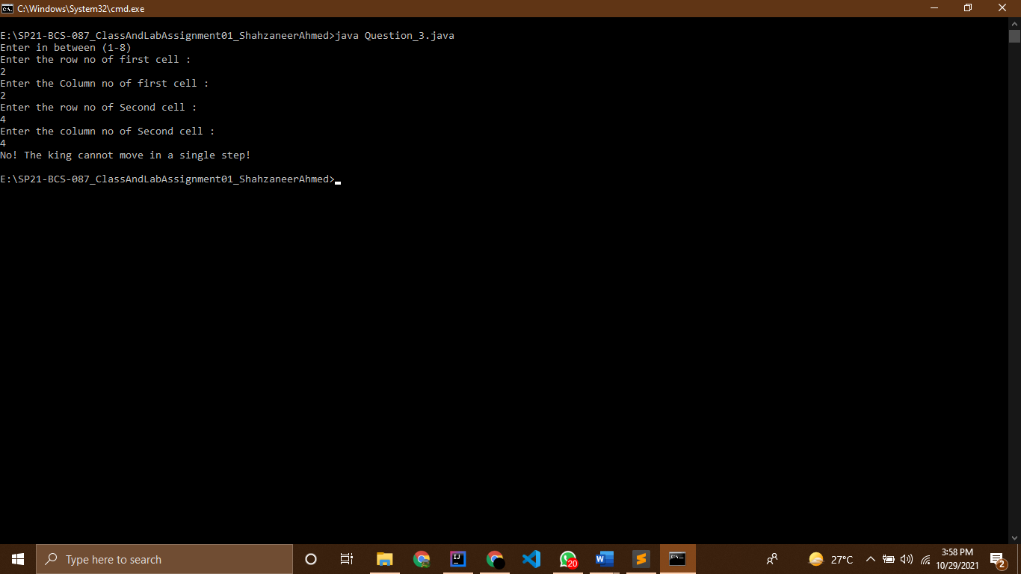

Question 4

Source Code

// |----------------------------------------------------------|

// |------------------Shahzaneer Ahmed------------------------|

// |-------------------SP21-BCS-087---------------------------|

// |----------------------------------------------------------|

//Question – 4:

// Write a program that prompts the user to enter an integer and determines whether it is divisible

// by 5 and 6, whether it is divisible by 5 or 6, and whether it is divisible by 5 or 6, but not both.

// Here is a sample run of this program:

import java.util.Scanner;

public class Question_4 {

public static void main(String[] args) {

Scanner obj = new Scanner(System.in);

System.out.println("Enter any Integer :");

int integer = obj.nextInt();

boolean divisibleOr = false , divisibleAnd = false , divisibleXor = false;

if ((integer%5==0) && (integer%6==0)) divisibleAnd = true;

if ((integer%5==0) ^ (integer%6==0)) divisibleXor = true;

if((integer%5==0) || (integer%6==0)) divisibleOr = true;

System.out.printf("IS The integer %d divisible by 5 and 6 ? : %b\n" ,integer,divisibleAnd);

System.out.printf("IS The integer %d divisible by 5 or 6 ? : %b\n" ,integer,divisibleOr);

System.out.printf("IS The integer %d divisible by 5 or 6 but not both? : %b\n" ,integer,divisibleXor);

}

}

Screenshots

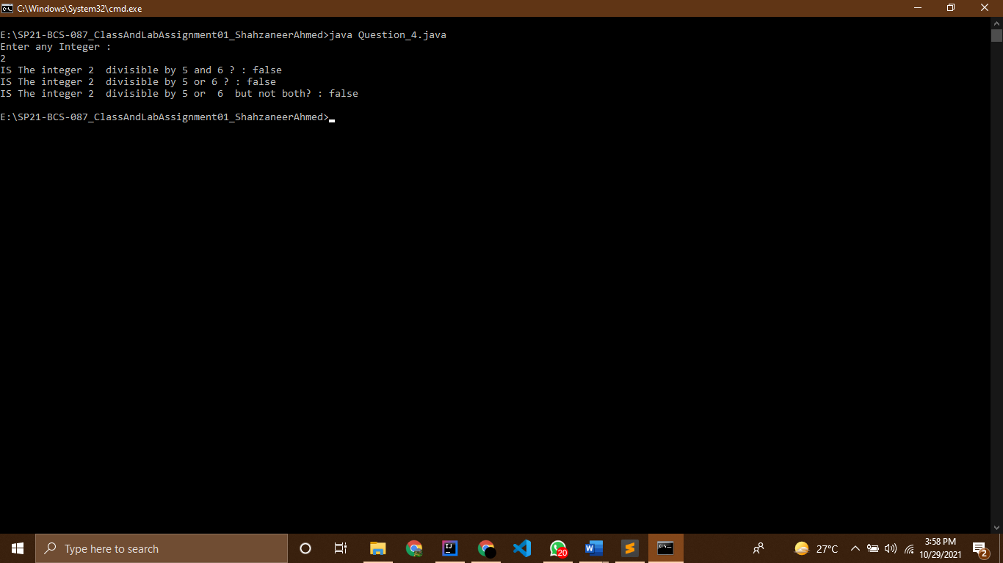

Question 5

Source Code

// |----------------------------------------------------------|

// |------------------Shahzaneer Ahmed------------------------|

// |-------------------SP21-BCS-087---------------------------|

// |----------------------------------------------------------|

//Question – 5: CLO-1

// Write a program that calculates and prints the monthly paycheck for an employee. The net pay

// is calculated after taking the following deductions:

// Federal Income Tax: 15%

// State Tax: 3.5%

// Social Security Tax: 5.75%

// Medicare/Medicaid Tax: 2.75%

// Pension Plan: 5%

// Health Insurance: $75.00

// Your program should prompt the user to input the gross amount and the employee name.

// Format your output to have two decimal places. A sample output follows:

//

import java.util.Scanner;

public class Question_5 {

public static void main(String[] args) {

Scanner obj = new Scanner(System.in);

System.out.println("Enter your name :");

String employeeName = obj.nextLine();

System.out.println("Enter your Gross Amount :");

double grossAmount = obj.nextDouble();

double federalIncomeTax , stateTax, socialSecurityTax, medicareTax, pensionPlan, healthInsurance, netPay;

federalIncomeTax = grossAmount*0.15;

stateTax = grossAmount*(3.5/100);

socialSecurityTax = grossAmount*(5.75/100);

medicareTax = grossAmount*(2.75/100);

pensionPlan = grossAmount*0.05;

healthInsurance = 75.00;

double cutPay = federalIncomeTax+stateTax+socialSecurityTax+medicareTax+pensionPlan+healthInsurance;

netPay = grossAmount - cutPay;

System.out.printf("%s\n",employeeName);

System.out.printf("Gross Amount: $ %10.2f\n",grossAmount);

System.out.printf("Federal Tax : $ %10.2f\n",federalIncomeTax);

System.out.printf("State Tax : $ %10.2f\n",stateTax);

System.out.printf("Social Security Tax: $ %10.2f\n",socialSecurityTax);

System.out.printf("Medicare Tax: $ %10.2f\n",medicareTax);

System.out.printf("Pension Plan: $ %10.2f\n",pensionPlan);

System.out.printf("Health Insurance: $ %10.2f\n",healthInsurance);

System.out.printf("Net pay : $ %10.2f\n",netPay);

}

}

Screenshots

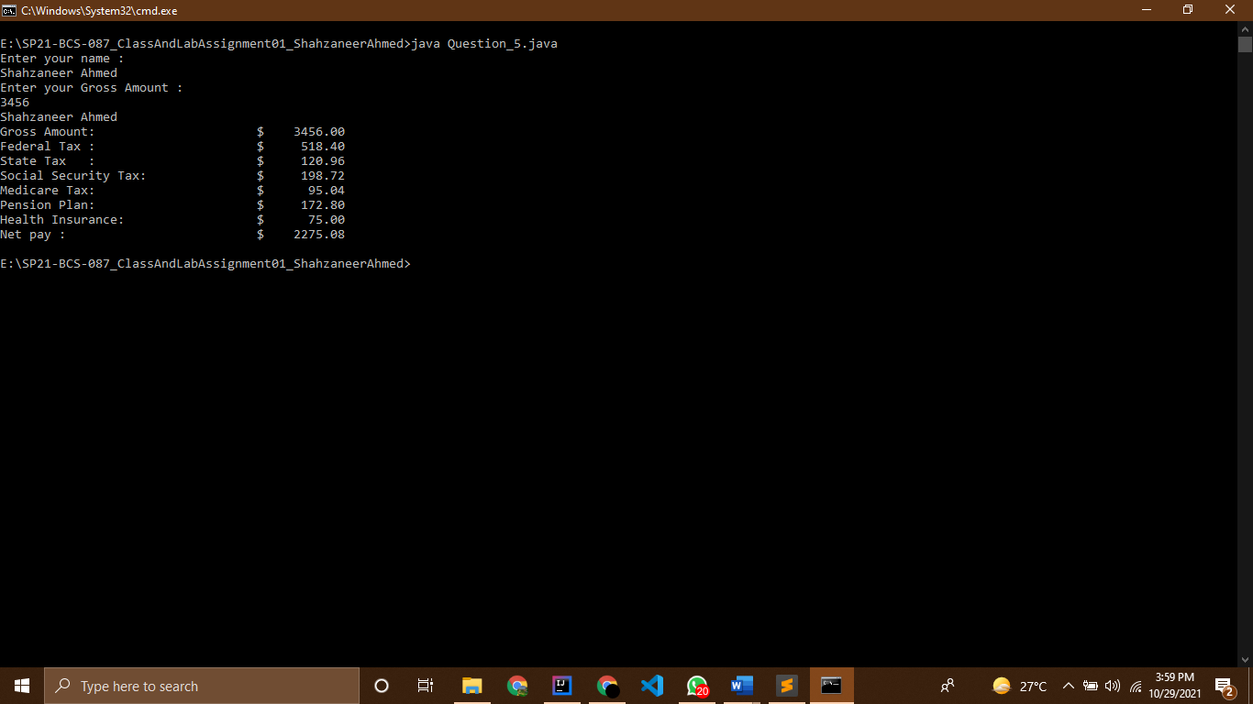

Question 6

Source Code

// |----------------------------------------------------------|

// |------------------Shahzaneer Ahmed------------------------|

// |-------------------SP21-BCS-087---------------------------|

// |----------------------------------------------------------|

//Question – 6:

// Mr. Ahmad would like to withdraw X $US from an ATM. The cash machine will only accept the

// transaction if X is a multiple of 5, and Ahmad's account balance has enough cash to perform the

// withdrawal transaction (including bank charges). For each successful withdrawal the bank

// charges 0.50 $US. Calculate Ahmad's account balance after an attempted transaction.

// Input

// Positive integer 0 < X <= 2000 - the amount of cash which Ahmad wishes to withdraw.

// Nonnegative number 0<= Y <= 2000 with two digits of precision - Ahmad's initial account

// balance.

// Example - Successful Transaction

// Input: 30 120.00

// Output: 89.50

// Example - Incorrect Withdrawal Amount (not multiple of 5)

// Input: 42 120.00

// Output: 120.00

// Example - Insufficient Funds

// Input: 300 120.00

// Output: 120.00

import java.util.Scanner;

public class Question_6 {

public static void main(String[] args) {

Scanner obj = new Scanner(System.in);

System.out.println("Enter Ahmad's initial Account balance :");

double initialAmount = obj.nextDouble();

System.out.println("Enter the amount for withdrawal :");

double withdrawalAmount = obj.nextDouble();

double transactionFee = 0.5;

// declaring boolean values to be used

// if (initialAmount>withdrawalAmount){

// withdrawalPossible = true;

// }

boolean withdrawalPossible = initialAmount > withdrawalAmount;

boolean correctWithdrawal = withdrawalAmount%5==0;

boolean insufficientFunds = initialAmount < withdrawalAmount;

double newAmount;

//logic implementation using nested conditional structure

if (withdrawalPossible){

if (correctWithdrawal){

newAmount = initialAmount - (withdrawalAmount + transactionFee);

System.out.printf("input : %.2f \n output : %.2f \n" ,withdrawalAmount,newAmount);

}

else{

System.out.printf("input : %.2f \n output : %.2f \n ",withdrawalAmount , initialAmount);

}

}

if (insufficientFunds){

System.out.printf("input : %.2f \n output : %.2f \n ",withdrawalAmount , initialAmount);

}

// logic implementation using relational operators

// if (withdrawalPossible && correctWithdrawal) {

// newAmount = initialAmount - (withdrawalAmount + transactionFee);

// System.out.printf("input : %.2f \n output : %.2f \n" ,withdrawalAmount,newAmount);

// }

// else if (withdrawalPossible && (!correctWithdrawal)) {

//

// System.out.printf("input : %.2f \n output : %.2f \n" ,

// withdrawalAmount,initialAmount);

// }

// else if (insufficientFunds) System.out.printf("input : %.2f \n output : %.2f \n" ,withdrawalAmount,initialAmount);

}

}

Screenshots

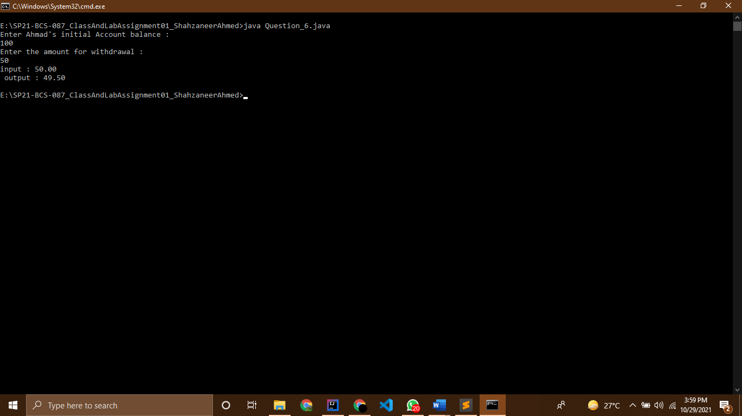

Question 7

Source Code

// |----------------------------------------------------------|

// |------------------Shahzaneer Ahmed------------------------|

// |-------------------SP21-BCS-087---------------------------|

// |----------------------------------------------------------|

//Question-7

// School students like to play a game in which they have blocks each denoting some integer from

// 0 to 9. These are arranged together in a random manner without seeing to form different

// numbers keeping in mind that the first block is never a 0. Once they form a number they read in

// the reverse order to check if the number and its reverse is the same. If both are same then the

// player wins.

// Now they want to simulate the same in computer. For simulating, the first step is to take input

// (a number) from the user and check if the number and its reverse number are same or not. If

// the number and its reverse number are same then user wins otherwise user loses the game.

// Input: An integer N (3 digit number Only)

// Output: Win/Lose

// Example Win

// Input: 323

// Output: Win

// Example Lose

// Input: 445

// Output: Lose

import java.util.Scanner;

public class Question_7 {

public static void main(String[] args) {

Scanner obj = new Scanner(System.in);

System.out.println("Enter a three digit num");

int num = obj.nextInt();

int number = num;

int rev = 0;

while (num != 0) {

int lastDigit = num%10;

rev = rev * 10 + lastDigit;

num = num/10;

lastDigit = num%10;

rev = rev * 10 + lastDigit;

num = num/10;

lastDigit = num%10;

rev = rev * 10 + lastDigit;

num = num/10;

}

if (number == rev) System.out.println("You won!");

else System.out.println("You lose!");

}

}

Screenshots

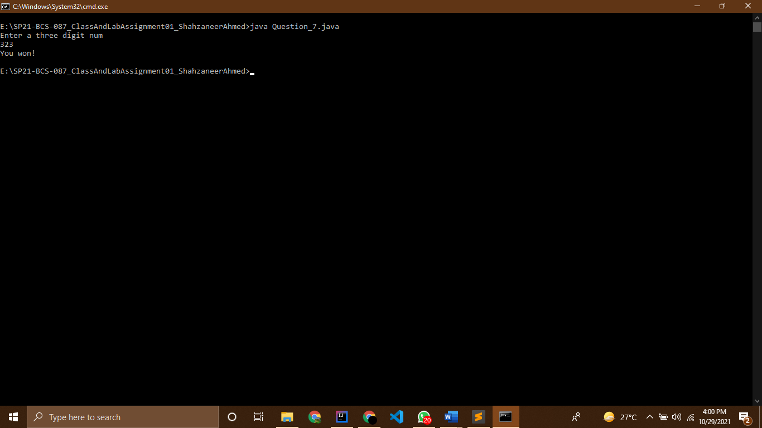

Question 8

Source Code

// |----------------------------------------------------------|

// |------------------Shahzaneer Ahmed------------------------|

// |-------------------SP21-BCS-087---------------------------|

// |----------------------------------------------------------|

//Question-8

// A shipping company uses the following function to calculate the cost (in dollars) of shipping

// based on the weight of the package (in pounds).

// Write a program that prompts the user to enter the weight of the package and display the

// shipping cost. If the weight is greater than 50, display a message “the package cannot be

// shipped.”

import java.util.Scanner;

public class Question_8 {

public static void main(String[] args) {

Scanner obj = new Scanner(System.in);

System.out.println("Enter the weight of object in pounds to be shipped : ");

double weight = obj.nextDouble();

if ((weight>0) && (weight<=1)) System.out.println("The shipping cost is $ 3.5");

else if ((weight>1) && (weight<=3)) System.out.println("The shipping cost is $ 5.5");

else if ((weight>3) && (weight<=10)) System.out.println("The shipping cost is $ 8.5");

else if ((weight>10) && (weight<=20)) System.out.println("The shipping cost is $ 10.5");

else if (weight>=50) System.out.println("The package cannot be shipped");

}

}

Screenshots

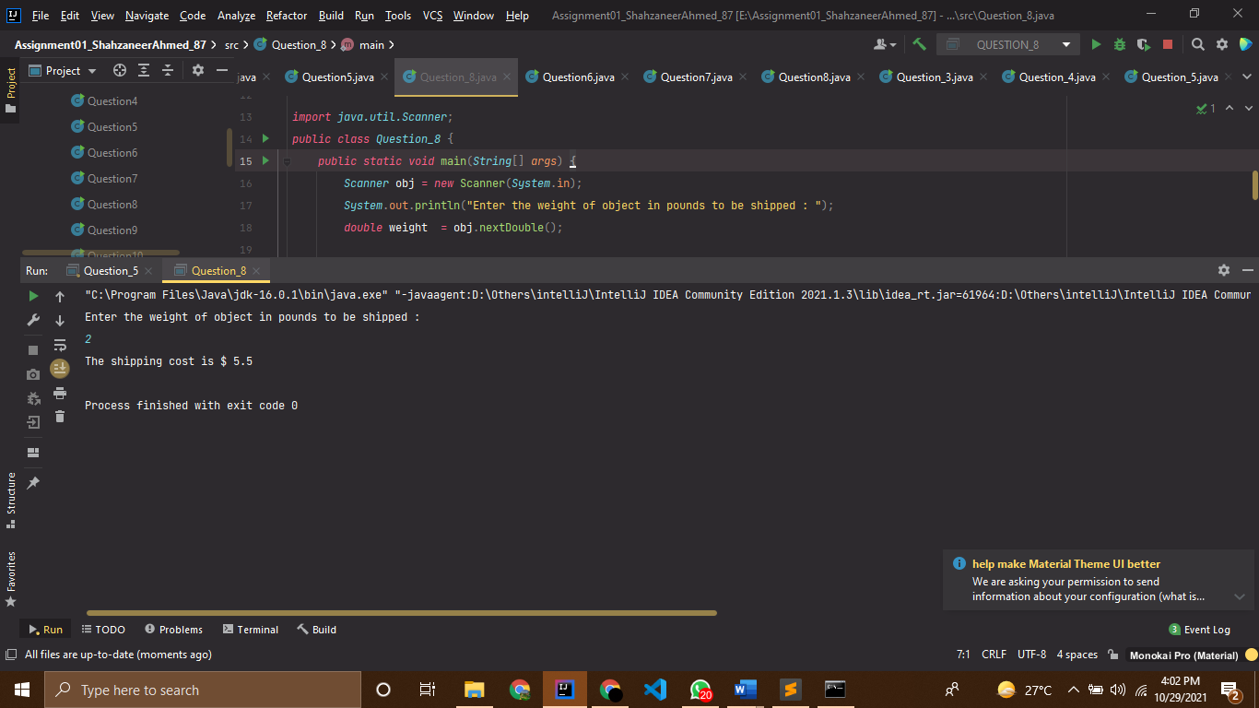

Question 9

Source Code

// |----------------------------------------------------------|

// |------------------Shahzaneer Ahmed------------------------|

// |-------------------SP21-BCS-087---------------------------|

// |----------------------------------------------------------|

//Question-9

// Zeller’s congruence is an algorithm developed by Christian Zeller to calculate the day of the

// week. The formula is

// Where

// ▪ h is the day of the week (0: Saturday, 1: Sunday, 2: Monday, 3: Tuesday, 4: Wednesday,

// 5: Thursday, 6: Friday).

// ▪ q is the day of the month.

// ▪ m is the month (3: March, 4: April, …, 12: December). January and February are counted

// as months 13 and 14 of the previous year.

// ▪ j is the century (i.e., year / 100).

// ▪ k is the year of the century (i.e., year % 100).

// Note that the division in the formula performs an integer division. Write a program that prompts

// the user to enter a year, month, and day of the month, and displays the name of the day of the

// week. Here are some sample runs:

//

// (Hint: January and February are counted as 13 and 14 in the formula, so you need to convert the

// user input 1 to 13 and 2 to 14 for the month and change the year to the previous year.)

import java.util.Scanner;

public class Question_9 {

public static void main(String[] args) {

Scanner obj = new Scanner(System.in);

System.out.println("Enter year : ");

int year = obj.nextInt();

System.out.println("Enter month (1-12) :");

int month = obj.nextInt();

System.out.println("Enter the day of the month (1-31):");

int monthDay = obj.nextInt();

int q = monthDay;

int m = month;

if (m == 1){

// as we have to consider m = 13 in case of 1 and year to be previous year!

m =13;

year-=1;

}

if (m == 2){

m =14;

year-=1;

}

int j = year/100;

int k = year%100;

int h = ( q + (26*(m+1)/10)+ k + (k/4) + (j/4) + (5*j)) % 7;

String todayDay = "";

switch (h) {

// using enhanced switch statement

case 0 -> todayDay = "Saturday";

case 1 -> todayDay = "Sunday";

case 2 -> todayDay = "Monday";

case 3 -> todayDay = "Tuesday";

case 4-> todayDay = "Wednesday";

case 5 -> todayDay = "Thursday";

case 6 -> todayDay = "Friday";

}

// System.out.printf("The year is %d\n", year);

// System.out.printf("The Month is %d \n", month);

// System.out.printf("The day of Month is %d\n", monthDay);

System.out.printf("Day of the week is %s\n",todayDay);

}

}

Screenshots

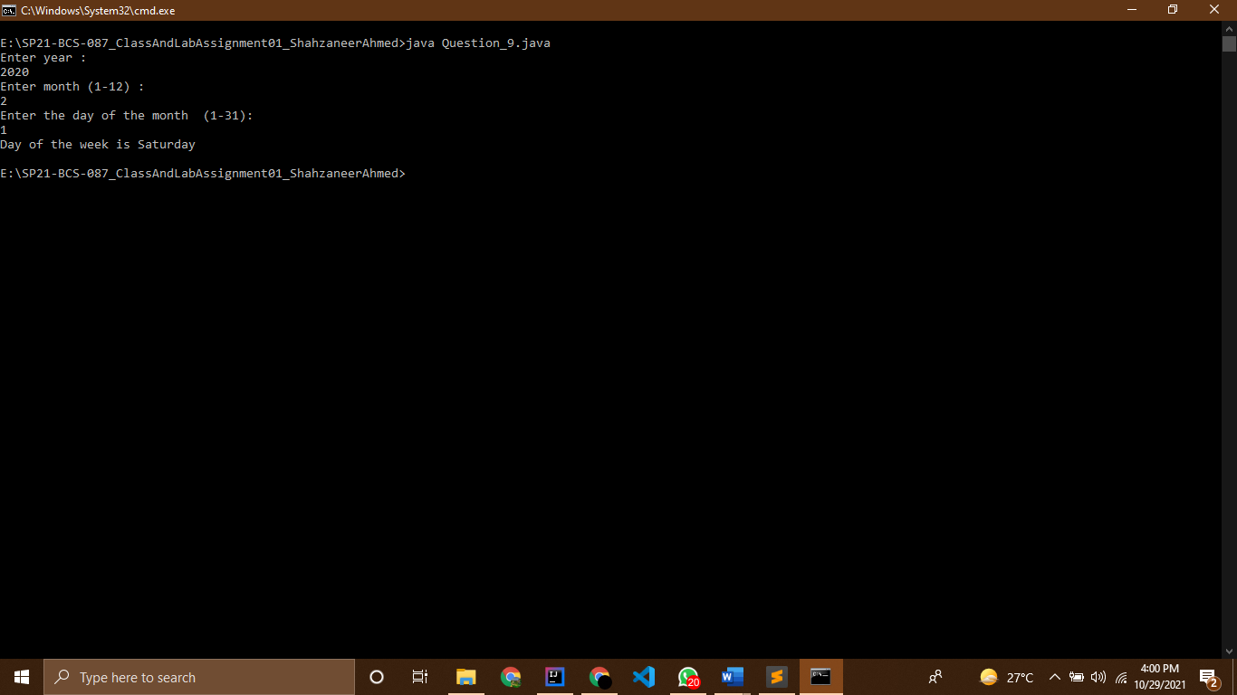

Question 10

Source Code

// |----------------------------------------------------------|

// |------------------Shahzaneer Ahmed------------------------|

// |-------------------SP21-BCS-087---------------------------|

// |----------------------------------------------------------|

//Question-10

// Write a program that prompts the user to enter a point (x, y) and checks whether the point is

// within the circle centered at (0, 0) with radius 10. For example, (4, 5) is inside the circle and (9,

// 9) is outside the circle, as shown in Figure

import java.util.Scanner;

public class Question_10 {

public static void main(String[] args) {

Scanner obj = new Scanner(System.in);

System.out.println("Enter the x- coordinate of the point :");

double x_coordinate = obj.nextDouble();

System.out.println("Enter the y- coordinate of the point :");

double y_coordinate = obj.nextDouble();

double x2 = (x_coordinate*x_coordinate);

double y2 = (y_coordinate*y_coordinate);

double distanceF = Math.pow((x2+y2),0.5);

int distanceFormula = (int) distanceF;

int radius = 10;

if (distanceFormula == 10) System.out.println("The point is on the circle !");

else if (distanceFormula > 10) System.out.println("The point is outside/not inside the circle !");

if (distanceFormula < 10) System.out.println("The point is inside the circle !");

// System.out.println(distanceFormula);

}

}

Screenshots

